**Quality requirements about winter maintenance**

* if company spots a danger, you must inform about it
* when people are moving at streets, they should be able to trust that is safe to walk, drive or move
* Surface should be clean and rough enough to prevent falling down or any kind of slipperiness
* Bicycle and pedestrian routes should clean whole route according to quality category
* If the weather is exceptional, then is possible to clean the routes slower speed.

**Different kinds of water**

* snow
* slush
* ice
* ice and water (most slippery)

**Order of plowing snow**

Different time requirements for different quality categories

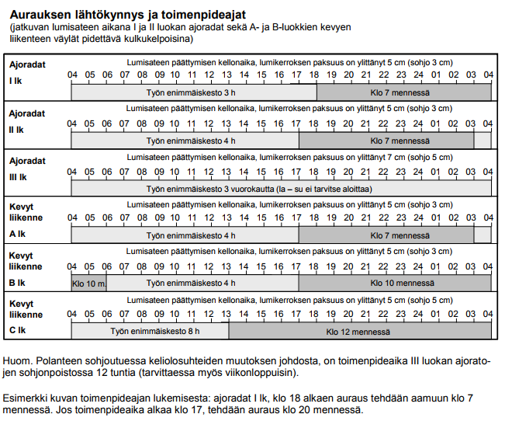

White = maximum time of work

Grey = which time the surface should be clean

**Order of slippery prevent**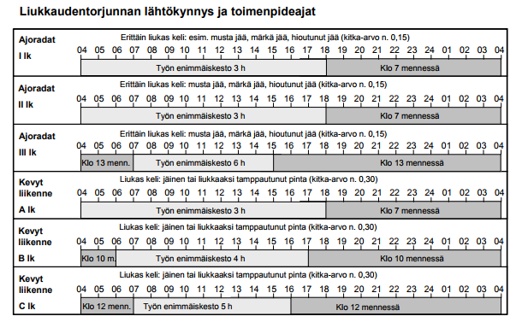

White = maximum time of work

Grey = which time the surface should be clean

Slipperiness is prevented by using sand or salt (CaCl solution).

**Sand removal**

At spring sand must remove from streets. If sand removal is started too early there might be slipperiness according to different weather conditions (high humidity or rainfall combined to temperature below zero). These weather conditions cold also harm the working equipment because of water is freezing and damaging pipes.